Tutorial 10: WLAN Concept and WLAN Configuration

WLAN Concept
- List the IEEE standard for the following wireless network.

  - Wireless Personal-Area Network (WPAN)
  - Wireless LAN (WLAN)
  - WiMAX (Worldwide Interoperability for Microwave Access)

- WPAN
  - Low power / short-range (20-30 ft)
  - IEEE 802.15 standard
  - 2.4 ghz
  - Example: Bluetooth / Zigbee
- WLAN
  - IEEE 802.11 standard
  - Medium sized network (300 feet)
  - 2.4 ghz / 5ghz / 6ghz
- WiMAX
  - IEEE 802.16 standard (30 miles / 50 km)
  - Long range Internet access
- Which 802.11 standards use both the 2.4GHz and 5 GHz radio frequencies?

- IEEE 802.11n
- IEEE 802.11ax

- What are the functions of a wireless router?

- Access point (provide wireless access)
- Switch (4 ports, full duplex, 10/100/1000 mbps Ethernet switch for wired devices)
- Routing service (provide default gateway for connection to other networks - Internet)

- Wireless Access Points (APs) can be categorized as either autonomous APs or controller-based APs. Differentiate between autonomous access points (APs) and controller-based APs.

- Autonomous access points (APs)
  - Standalone device configured manually via CLI or GUI by admin.
  - Each APs act independently of others
- Controller-based APs
  - Lightweight AP
  - Use LWAP lightweight access point protocol to communicate with WLAN controller (WLC)
  - Each AP is automatically configured or managed by WLC.
- WLANs use carrier sense multiple access with collision avoidance (CSMA/CA) as the method to determine how and when to send data on the network. Explain CSMA/CA.

- Listen to the channel to check the idle channel.
- Sends RTS - request to send to AP to request access to the network.
- AP will send CTS-clear to send messages to grant access to the network.

- If a client does not receive a CTS message, it waits a random period of time before restarting the previous process.
- After receiving CTS, it will send the data. All transmission will receive acknowledgment.
- If no acknowledgment is received, collision happens / it restarts the process.
- The saturation of the wireless medium degrades the quality of the communication. Over the years, a number of techniques have been created to improve wireless communication and alleviate saturation. These techniques mitigate channel saturation by using the channels in a more efficient way. List the THREE (3) frequency channel saturation techniques.

- DSSS (802.11b)
- FHSS (802.11 earlier version)
- OFDM (802.11a/g/n/ac/ax)
- In the 2.4 GHz WLANs that used multiple APs with same channel, interference occurs when one signal overlaps a channel reserved for another signal, causing possible distortion. How do you solve this problem?

Best practise for 2.4ghz to avoid overlapping channels
- Use channels 1, 6, 11
- Explain man-in-the-middle (MITM) attack in a WLAN environment.

- Hacker positioned in between 2 legitimate entities.
- Hackers can read or modify the data that passed between 2 parties.
- Can steal personal info, gain access to device, compromise system
- For example, create rogue AP / Evil Twin for free wifi (hotel, airport, cafes).

- A rogue access point (AP) refers to a wireless access point installed within a corporate network without official approval, violating the organisation's policies.
- Examine the security risks associated with rogue APs.

- Capture MAC address, data packets
- Gain access to network resources
- Launch MITM attack

- Provide ONE (1) example of how a rogue AP can be introduced into a corporate network.

Create fake personal hotspot

- Discuss ONE (1) strategy that an organisation can implement to mitigate the threat of rogue AP attacks.

- Configure Wireless controller (WLC)
  - policies to monitor active hotspot for unauthorized APs

- WPA2 authentication are commonly configured in wireless routers. Explain TWO (2) WPA2 authentication methods that are available for selection while configuring wireless routers.

- WPA2 Personal PSK (Pre-Shared Key)
  - Authentication with wireless router with pre-shared password.
- WPA2 Enterprise
  - Require a RADIUS (remote authentication dial-in user service) authentication server.
  - Complicated to setup when providing additional security.
  - Devices must be authenticated by RADIUS server (802.1X standard / Extensible Authentication Protocol (EAP)) - digital certificate / smart card / domain user password.

WLAN Configuration

- List down steps for the basic wireless setup.

- View default WLAN default login.
- Change the network mode .
- Configure SSID (wifi network name).
- Configure channel.
- Configure security mode.
- Configure the passphrase.

- Briefly explain Network Address Translation (NAT) based on the IP address given shown in Figure 10.1.

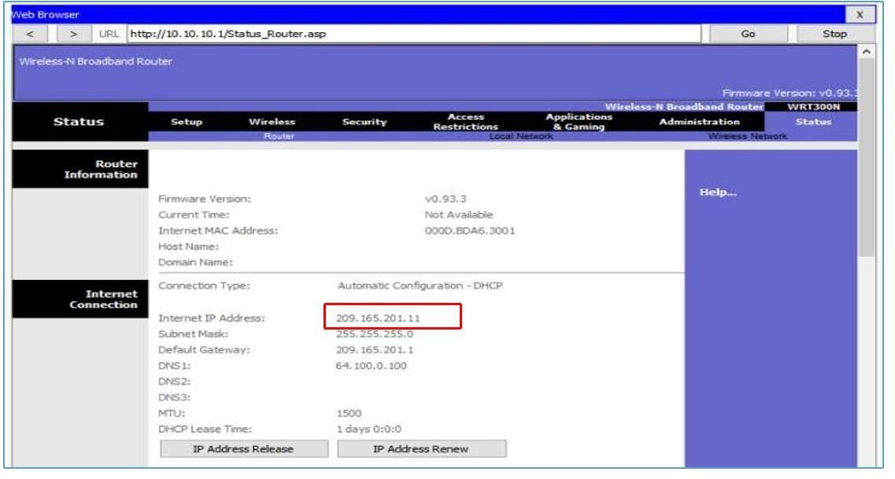
Figure 10.1 Status Page of a wireless router

- 209.165.201.11 is public IPv4 routable on the Internet.
- Any address with private IPv4 10.x.x.x cannot be routed on the Internet.
- Router will use NAT to convert the IPv4 private address to the public routable address.
- With NAT, a private IP (local) is translated to a public (global) address.

- Many wireless routers have an option for configuring Quality of Service (QoS). Why need to configure QoS?

- QoS guarantees certain traffic (voice, video streaming) are prioritized over other application traffic that are not time-sensitive (email, web browsing).
- Some wifi router, QoS can be configured to be prioritized on specific ports (TCP, UDP).

